# IN721 2019 4.2 - Data Passing Between Activities

## Task 1: Passing Data When Launching

Build an app as follows:

* The app has two screens: a main activity screen (which at the moment doesn’t do anything much) and a settings screen.
* The user can navigate from the main screen to the settings screen via a button.
* On the settings screen, the user can specify a username.
* Usernames must be at least 3 characters long. Provide appropriate feedback if the proposed username is too short.
* The user can navigate back from the settings screen to the main screen via a button control (i.e. **they do not need to use the phone’s hardware back button**).
* When the user returns to the main screen after specifying a username, the username is displayed on the main screen.
* **NB: You are not required to maintain state in this application.** It is ok if, when you go to Settings a second time, type in no username, and return to main, the username will be gone. **You just need to pass the contents of the EditText on the Settings Activity to the onCreate method of the Main Activity**. We will look at maintaining state later.

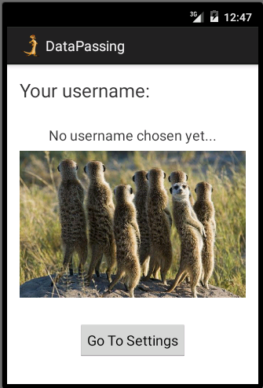 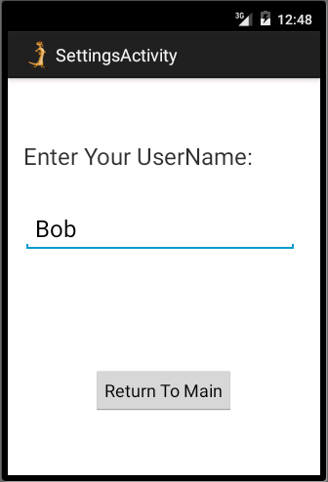 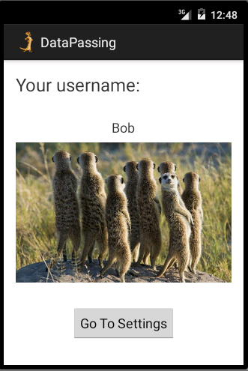

At launch At Settings, user types Return to Main

## Task 2: Requesting Data

Build an app as follows:

* The app has two Activities: Main and Settings.
* The screen of the Settings Activity has a TextView control whose text colour has been set at design time (for simplicity).
* The application opens on the Main screen.
* The Main screen has a TextView control that initially contains black text.
* The Main screen has a button.
* When that button is pressed, the text colour of the Main screen changes to that of the coloured TextView on the Settings screen.
* Note that at runtime **the user never sees the Settings Activity screen**. To the user, all that changes on button press is the text colour of the Main screen.
* To write this app you will need to research how to get and set the text colour properties of TextView controls.

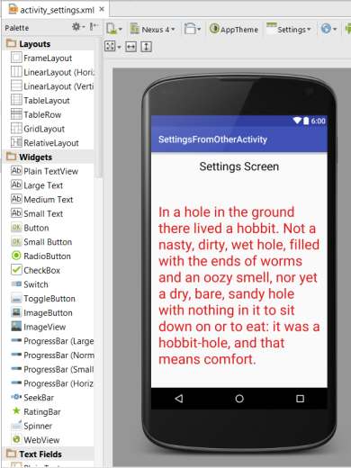

Settings Screen at Design Time (text colour has been set to #FF0000 in Properties window)

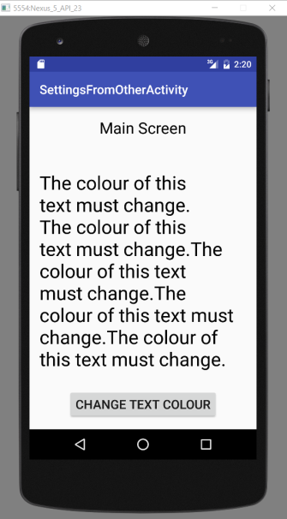 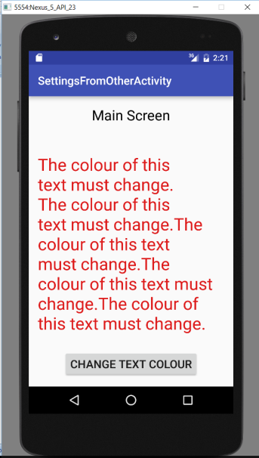

Main at runtime before button press (text is black) Main at runtime after button press (text is red)